1. a) For the osx system, we reprocessed the data. We used ffmpeg program to transform the data format from .mp4 to .mp4. For Windows 10 system, we did not reprocess the data.

b) We did not encounter problems.

1. a) Yes. No corruption. We used QuickTime Player for mac and Windows Media Player for Windows 10 to play the video.
2. We did not encounter problems when playing the video.
3. a) We process the video with Matlab R2017a.

b) Problem:

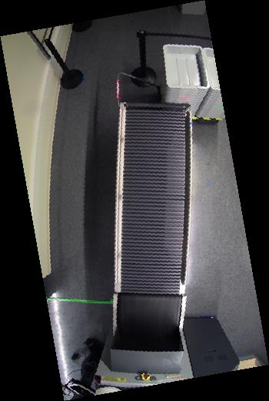For data collected on 6/21, we rotated the image by 110 degrees.

For data collected by ALERT on 7/21, I rotated the image by 100 degrees

1. 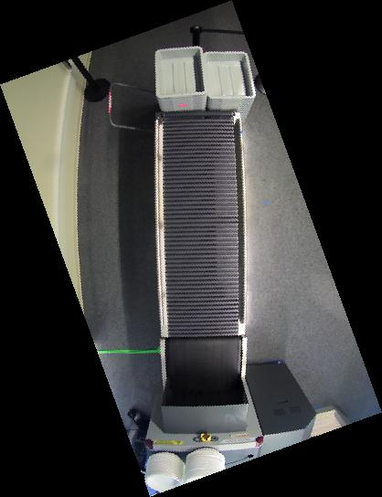We use OSX and Windows 10 operating system.
2. No.
3. a) So far the videos from camera 8, 9, 10, 11, 12, 13 is useful for developing our algorithm.

b) Currently all the actors in the videos pick their luggage correctly, in the future we may need scenes that someone picks up others’ luggage by mistake.

1. It would be better if the videos from different cameras can be jointly calibrated.